GIS Security Manager

GIS Security Manager is a tool designed by Budget to add users, grant access rights to users and monitor user activities etc on GIS.

Starting GIS Security Manager

To bring up the GIS Security Manager, run the GISS.exe file and log in using your designated username and password. The GIS Security Manager window appears with the User tab as the default tab and two buttons at the top of the screen. Now select the Refresh button on the top of the GIS Security Manager screen. A list of active GIS users will populate the GIS users column.

Adding Users

All users will be displayed in GIS users column. However, if you want to add a GIS user, go to the User tab and select New at the bottom of the screen. A New User window, as shown in Figure 1 will appear for you to enter the new user’s information. Blue highlighted fields are mandatory. Let’s say you want to add the user Andy Park.
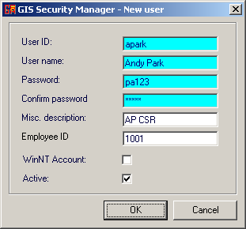
The naming convention for User ID is usually the first letter of the user’s first name with the last name appended to it. In this case, Andy Park’s User ID would be apark. The User name field is just the user’s full name. You also have to create a password for your new user and confirm it. The white fields are optional but it is always helpful if you include more details for reference. The Misc. description and Employee ID fields allow you to specify the department your new user belongs to and the new user’s employee ID (if any). Leave the WinNT Account box as is. Lastly, tick the Active box and click OK.
Figure 1: Adding a new user.

You have successfully added Andy Park as a new GIS user! But you also want to assign him some basic access rights as well as to restrict him from opening certain modules/reports in GIS. Let’s move on to the next section to see what we can do.

NOTE
You can deselect the Active box and click Refresh to see a list of inactive GIS users. These users are typically former users of GIS who can no longer access it.

Adding Groups and Assigning Group Permissions

When you assign permission rights to your user, it is always more efficient to group users together and assign the group access rights. That way, any changes made to the group’s access rights will apply to all its members as opposed to changing the access rights of each user individually.

To add a new group, switch to the Groups tab and click on the New button New at the bottom of the screen. A New Group window will pop up. Enter the name of your group and click OK. Let’s say you name your group Location CSR. Your newly added group will appear in the GIS user groups column and it will include all location customer service representatives (CSR).

To assign access rights, select a group from the GIS user groups column and you will see a list of all GIS modules in the GIS user group permissions column. Expand each module and you can select different permissions to assign to a user group. For example, in the Contract Check In module, you want to restrict your CSRs to checking in the vehicle and collecting the payment shown on GIS only. Therefore you would only select the View Record Only, View and Print Record and Full Access permissions (See Figure 2). Once you select a permission, this change is automatically saved. If you have a Location Manager user group, for example, then you may want to add the Contract Discount permission on top of all the permissions granted to the Location CSRs. If you have an Executive user group, then it would make sense to grant this group unrestricted access to all modules and reports.

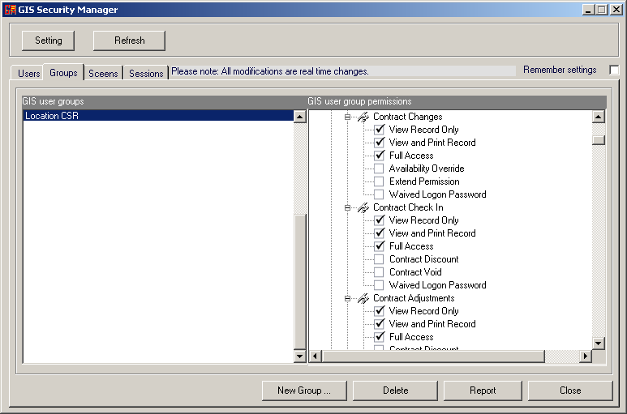
Figure 2: Assigning user group permission.
A Location CSR has permissions to the three selected actions, but s/he does not have the authority to do any of the unselected actions, like giving the customer a discount on a contract or void the contract.

Notice that the Waived Logon Password is not selected. As a rule of thumb, you should always configure GIS to prompt your users for password whenever they access a new screen.

Assigning User to a Group

Now that you have your user group all set up with permissions, you can assign your newly added CSR (remember Andy Park?) to your Location CSR user group. To do that, switch back to the Users tab. You will now see your Location CSR user group in the middle GIS user groups column. Select your user, and tick the box to the left of the Location CSR user group, as shown in Figure 3.

Andy Park is now assigned to the Location CSR user group and he will possess the rights you previously granted to the group.

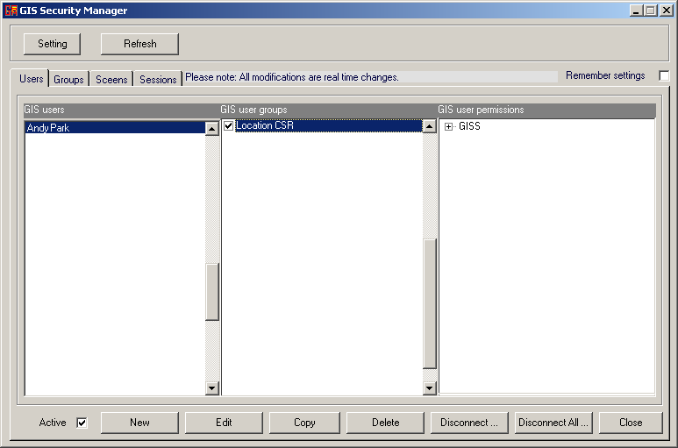
Figure 3: Assigning user to a group.

NOTE
You can assign more than one user group to each user.

Now that you understand the idea of assigning user permissions, you can create more user groups and assign your users to those groups as you see fit.
Monitoring User Activities

Go to the Sessions tab and to see a list of users who are currently logged on to GIS. You can also see the GIS screens and reports they have been using or have previously accessed, as shown in Figure 4.

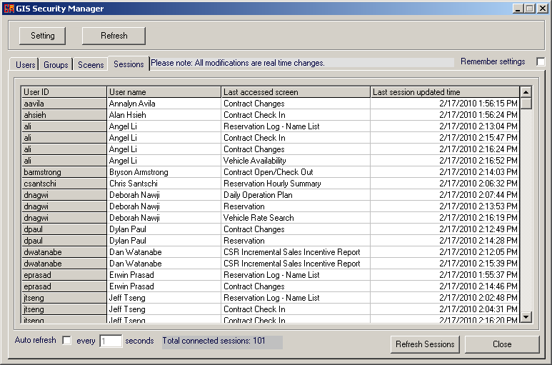
Figure 4: Monitoring user session.
A Location CSR has permissions to the three selected actions, but s/he does not have the authority to do any of the unselected actions, like giving the customer a discount on a contract or void the contract.

